Creating a class in Google Classroom
- Log in to classroom.google.com

- In the upper right corner click on the plus sign and then create class.
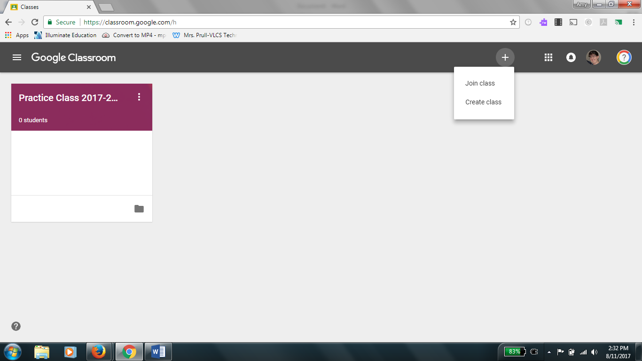

- Fill in the class name. Section and Subject are not necessary, but for specialty teachers it might be helpful to put the homeroom teacher’s name in section to help you keep track easily.

- A picture and color scheme will randomly be picked for your class, if you wish to change it in the bottom right corner of the picture you can choose a new theme or upload a photo for the background of the banner.
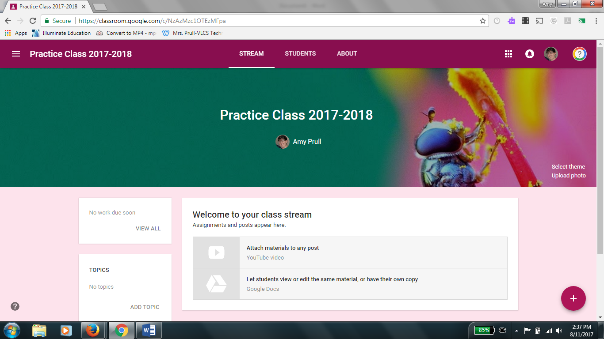

- To find the code to give students to join click on the students tab at the top. In the upper left the code will be displayed select it and choose display to have a large box with the code appear on the screen for students to enter.
