Creating Assignments, Questions, and Announcements in Google Classroom
1. Hover your mouse over the plus sign in the bottom right corner until the choices pop up.
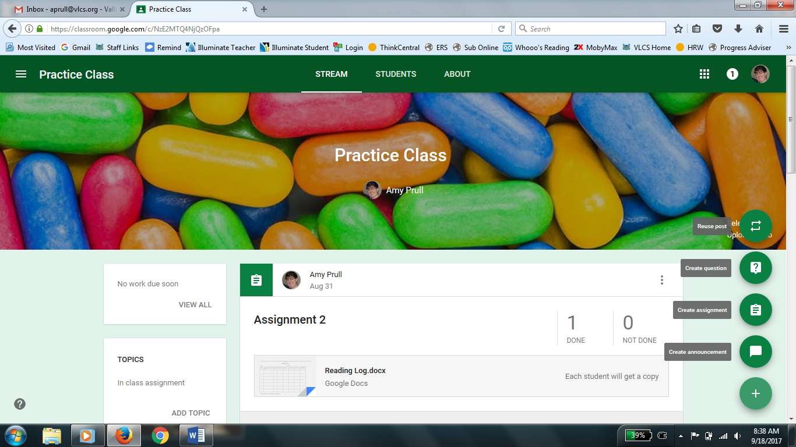
2. Click on Create Assignment to create an assignment. A box will pop up for you to fill in all the necessary information. You can decide if it for all students or just some by clicking the triangle by All students. Give the assignment a title and add any necessary instructions. If your assignment has a due date you can put it in. You do not have to put a time on that day that it is due, but you can if you want it by a certain time (such as the beginning of your class). If you are creating topics you can choose that as well. If there are any attachments upload those. You will need to choose if the students can just view the attachment (unable to edit it), if they all will edit the same copy (choose students can edit for this option), or if you want each student to have their own to turn in and edit (choose each student will get a copy). Click assign when done.
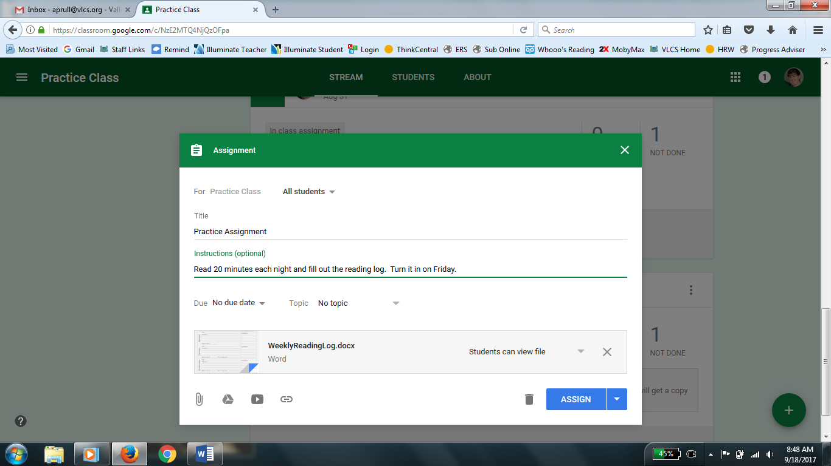

3. To create a question hover over the plus sign and select create question. A box will pop up for you to fill in all the necessary information. You can decide if it for all students or just some by clicking the triangle by All students. Type the question and any necessary instructions (such as to read something first). If your question has a due date you can put it in. You do not have to put a time on that day that it is due, but you can if you want it by a certain time (such as the beginning of your class). If you are creating topics you can choose that as well. If there are any attachments upload those. Students can only view any attachments, there is no editing option with a question. Choose if the question is short answer or multiple choice. If it short answer decide if students can reply to each other or not. If the slider is green they can reply to each other, if you want to turn it off slide it to the right. If it is gray, they cannot reply to each other. Also decide if students can edit their answer with the other slider. If it is a multiple choice question when you select it, it will allow you to add as many answer options as you wish. Click ask when you are finished.
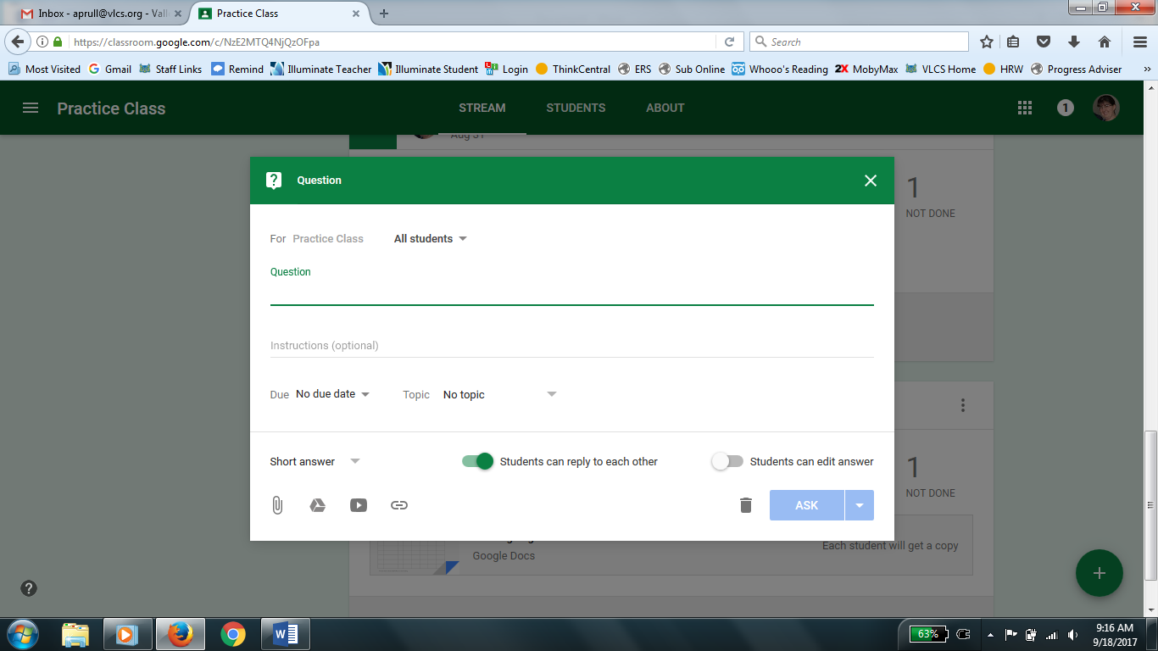
4. To create an announcement hover over the plus sign and select create announcement. A box will pop up for you to fill in all the necessary information. You can decide if it for all students or just some by clicking the triangle by All students. Type your announcement (such as field trip permission slips due Friday…). If you are creating topics you can choose that as well. If there are any attachments upload those. Students can only view any attachments, there is no editing option with a question, but parents can download and print the attachments. Click post when you are finished.
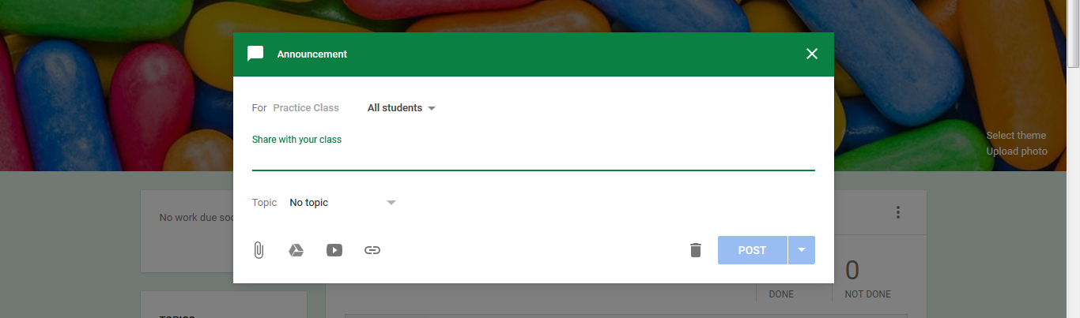

5. You can also reuse a post from another class. To reuse a post hover over the plus sign and select reuse post. A list of your classes will pop up, select the class the post you want to reuse is, find the post, click on it, at the bottom decide if you want to create new copies of all attachments and then click reuse. A box will pop up allowing you to edit anything from the old post before posting it. Make any necessary changes then click post/assign/ask.
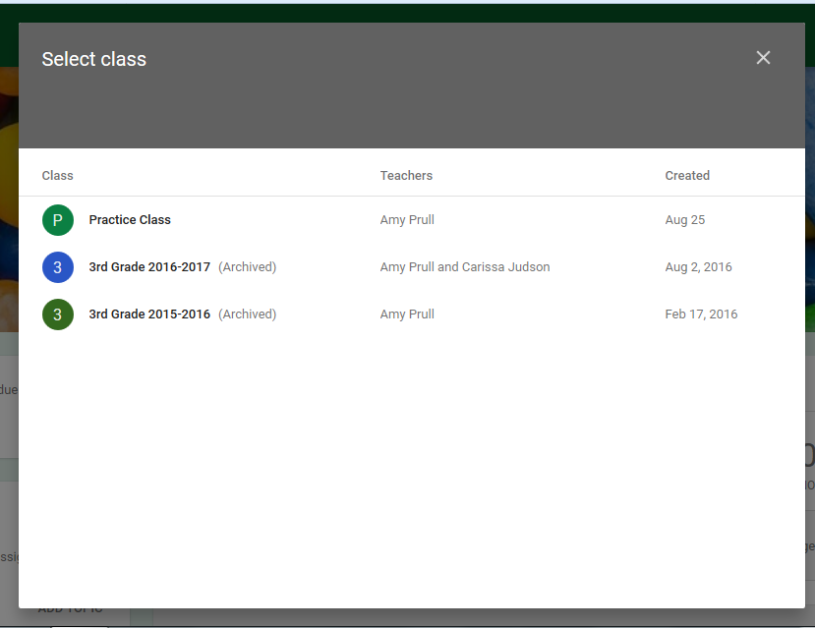
6. For any of these options you can schedule them to post at a later time by clicking on the triangle next to post/ask/assign and setting a date and time for them to post.

